|  |  |
| --- | --- |
|  | **FPT ACADEMY INTERNATIONAL**  **FPT – APTECH COMPUTER EDUCATION** |

Centre Name: **ACE-HCMC-2-FPT.**

Address: 391A Nam Ky Khoi Nghia, District 3, Ho Chi Minh City, Viet Nam.

**Music World**

|  |  |  |
| --- | --- | --- |
| Supervisor: | Phạm Thị Lánh | |
| Term: | 1 | |
| Batch No: | T1.2208.E0 | |
| Group No: | 1 | |
| Order: | Full name | Roll No. |
| 1. | Nguyễn Trí Hùng | Student1405204 |
| 2. | Châu Quang Diệu | Student1407999 |
| 3. | Đỗ Nguyên Chương | Student1405203 |
| 4. | Đỗ Trí Dũng | Student1407983 |

Month 12 Year 2022

 This is to certify that

|  |  |
| --- | --- |
| **Mr** | **Nguyen Tri Hung** |
| **Mr** | **Chau Quang Dieu** |
| **Mr** | **Do Nguyen Chuong** |
| **Mr** | **Do Tri Dung** |

**Have successfully Designed & Developed**

|  |
| --- |
| **MUSIC WORLD** |
| Submitted by: **Mrs. PHAM THI LANH** |
| Date of Issue: December, 2022 |
| Authorized Signature: |

# Content

Contents

Content 4

Acknowledge 6

Synopsis 7

REVIEW 1 8

Problem Definition 9

Customer Requirements Specification 10

Architecture and Design of the project 11

Site Map 12

Website Design Layout 13

I. Homepage 14

II. Header 15

III. Navigation side bar 20

IV. Main Content 27

V. Music Player 27

REVIEW 2 29

Website User Interface 30

I. Homepage 30

II. Header 31

III. Navigation side bar 36

IV. Main Content 41

V. Music Player 42

Task Sheet 43

Testing document 45

Final checklist 46

References 47

# Acknowledge

While working on this eProject, we learned much value about how a website work in practical, how important of teamwork to accomplish an project together.

We gained a lot of skills and knowledge such as:

* Practice step by step i.e., laddered approach.
* Build a larger, more robust application.
* Usage of certain utilities in applications designed by the user.
* Single program to unify code leading to a complete application.
* Learn implementation of concepts in a phased manner.
* Enhance skills and add value.
* Work on real life projects.
* Give a real-life scenario and help to create applications that are more complicated and useful.

We would like to thank each member of our team, who have been working hard to accomplish the project on time.

We love to say many thanks to our lecture - Mrs. Pham Thi Lanh – Who has guided and supported us during working on this project.

Our eProject may not be perfect, but we tried hard with support from FPT staff and Aptech staff. We appreciate that.

Your Sincerely,

eProject Group 1.

# Synopsis

The Objective of this program is to give a sample project to work on real life projects. These applications help you build a larger more robust application.

The objective is not to teach you JavaScript/Dreamweaver but to provide you with a real-life scenario and help you create basic applications using the tools.

This project is meant for students who have completed the module of HTML5. These programs should be done in the Lab sessions with assistance of the faculty if required.

It is essential that a student has a clear understanding of the subject. Students should go through the project and solve the assignments as per requirements given.

# REVIEW 1

## Problem Definition

Music has the power to cause emotions to well up within us. These feelings are gripping - often irresistible - and seem to emerge from nowhere. These feelings color our moods, affect our perceptions, and generate a behavioral pattern. The indisputable fact about music is its power to evoke emotions. Is there anyone for whom, music is completely emotional - neutral? Music has the ability to inevitably tap the still, mysterious deep well of our emotions. However, music can produce various emotional responses in different individuals and even different responses in the same person at different times. Music may produce expressions of various emotions - peaceful, relaxing, exciting, festive, boring, unsettling, unstimulating, invigorating ... and so on.

Music is an extremely versatile medium of communication. It is capable of exploring all the features that are used in verbal communication. Moreover, it does so in an explicit and structured way, which makes it an interesting and useful window into human communication, in general. Because of this there are many music stores across the city. And the competition for providing best of the music is growing very fast.

Hence it was felt that it would be good if there is a source where one can get all the related information. In today’s world internet is the best source for information sharing so a group of people took initiative in this and reached to a conclusion that a website is the best solution.

Regarding all those expectations, we would love to develop a music website that realizes our ideas.

The website is to be developed for the Windows Platform using HTML5, JavaScript and Geolocation. The site should work well in all leading browsers including Chrome, IE, Firefox etc.

Our website should bring features to users such as:

* Users would be able to find any music information that they need on the Homepage.
* Music Player should always be on top during interaction between user and website.
* Website’s interface should be displayed based on the user’s customization.
* Music should be classified or divided into detailed group such as Genre, Nation, Mood, Event, Instrument…
* Users would be able to give a like to song that they love, follow the artist, review or comment while listening to that song.

## Customer Requirements Specification

|  |
| --- |
| USER: |
| Input:  ● Input user information such as username, email.  ● Giving information about user’s personality |
| Process:  ● Process location data  ● Collect user’s information and conduct the analyzing data |
| Output:  ● Display information about music to user.  ● All information focusing on user’s experiences . |

|  |
| --- |
| WEBMASTER: |
| Input:  ● Control website database, input information, user customization… |
| Process:  ● Analyzing website |
| Output:  ● Website interface, images, forms, …  ● Giving interaction |

|  |
| --- |
| HARDWARE / SOFTWARE REQUIREMENT: |
| Software:  ● Notepad/HTML editor  ● Dreamweaver/JavaScript  ● IE 5.0/ Netscape 6.0 |
| Hardware:  ● A minimum computer system that will help you access all the tools in the courses is a Pentium 166 or better  ● 64 Megabytes of RAM or better |

## Architecture and Design of the project

The client-server architecture is a distributed application framework consisting of clients and servers in which server hosts, manages, and delivers client services. Clients are connected to a central server, and they communicate over internet connection through computer network. Whenever client needs any service, it sends a request to servers, which process the request and return response to the client.

Our project will be made up by using HTML5, CSS, JavaScript.

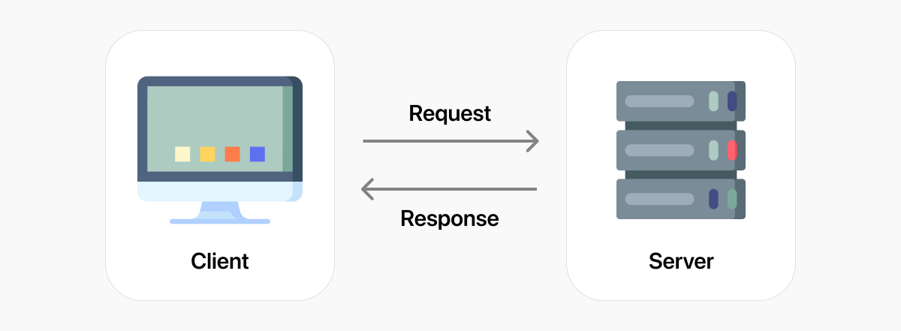

## Site Map

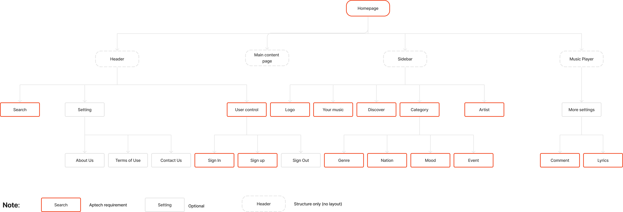

## Website Design Layout

This website will be created with the main purpose of focusing on user experiences. We develop 4 main factors in which:

1. Header: Including Search box, Setting, User Control. This header will persistently exist through all interactivity with user.
2. Navigation Side bar: Including some menus such as: Your Music (your library), Discover (Explore), Category (including genre, mood, nation, artist, instruments, topmost listening…). This Navigation bar will persistently exist during all interactivity with users.
3. Main content: It will display relevant information when user clicks on link of Navigation Sidebar
4. Music Player: This Player stays still during all interactivity with users, user will be able to play song, pause, play next song, play previous song, seek forward or backward of song, turn the volume on or off.

That above information will be detailed in the following layouts.

### Homepage

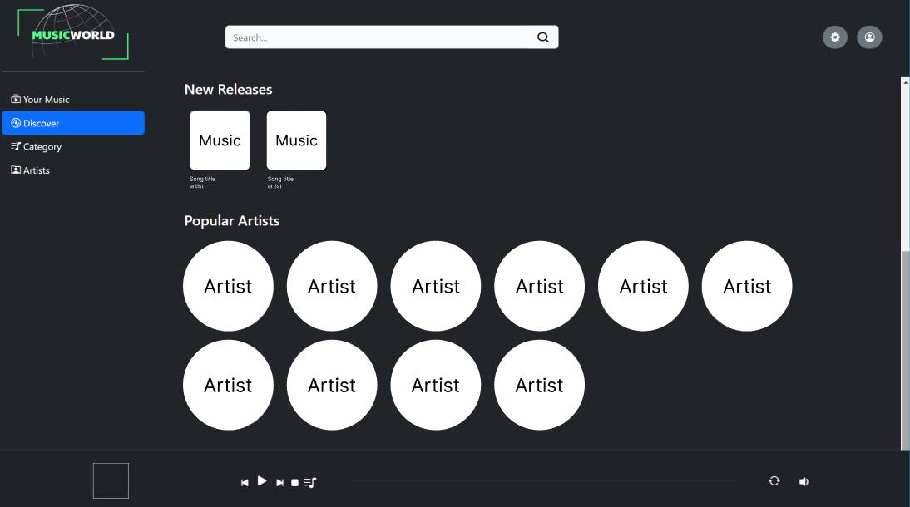

**Description**: When a user surfs the website for the first time, this Homepage will be displayed with structure as shown in Figure 2.

Details:

1. Logo of Music World.
2. Header: Including Search box, Setting button, User Control.
3. Navigation Side bar: This menu includes Your Music World (user’s library), Discover, Category (which is classified in sub-category such as Genre, Nation, Mood).
4. Main content: this layout is scrollable to display content such as new releases, topmost listen, artist, playlist by events, playlist by mood…
5. Music Player: This player will stay still throughout the interactivity between user and website.

### Header

#### User Control

##### Sign In

Users need to sign in to enable full feature of the site. Otherwise, users are just guests and limited functions will be applied to guests. Once the user has sign up or sign in, they will be able to download song from website.

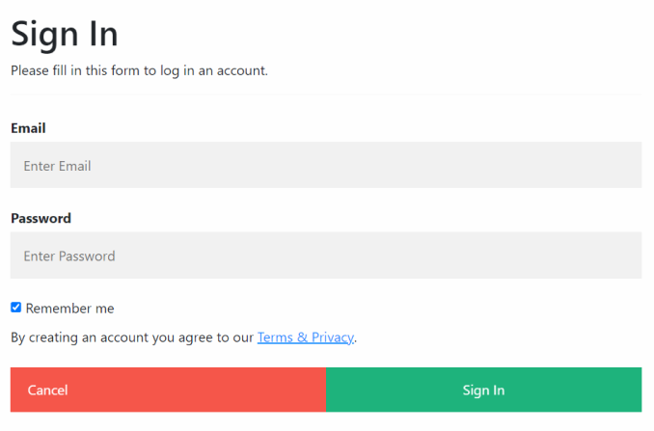

##### Sign Up

If users have not registered an account, they need to sign up for one, then they could access the site with full features of registered users.

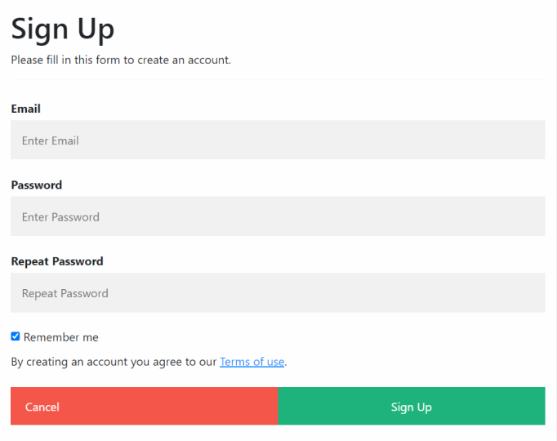

#### Setting Control

When clicking on Setting button, the setting panel will appear as following menu: About Us and Terms of Use.

In order to maximize User’s experience, all information in footer will be moved to Setting Control. This helps save space for the Music Player always on top.

##### About Us

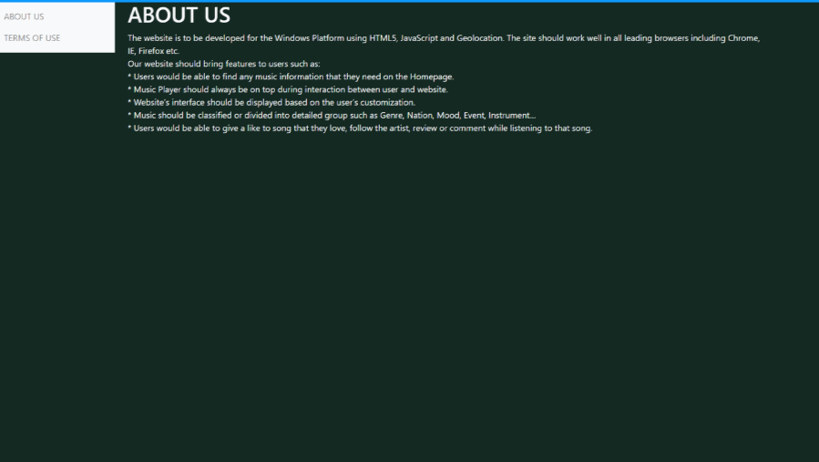

##### Terms of use

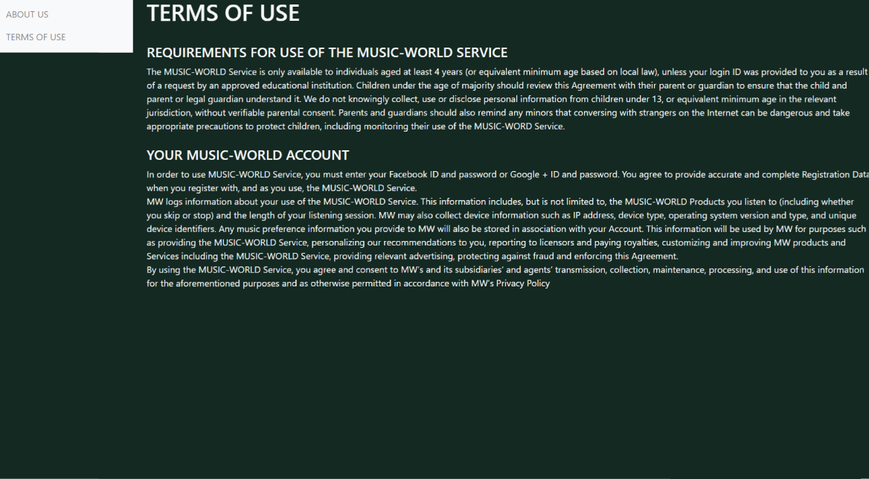

#### Search box

Search box provides search function for user to look for information such as song name, artist name, releases date of album…

When user do a search, result will appear directly on that page while typing keyword. Search function is available across menu pages, user can search in any page of sidebar.



### Navigation side bar

#### Your Music

All information about user activity will be collected and shown in Your Music menu. For instance, Song that you play will be added as playlist in this menu.

This page also shows information about lyrics of songs that are currently playing.

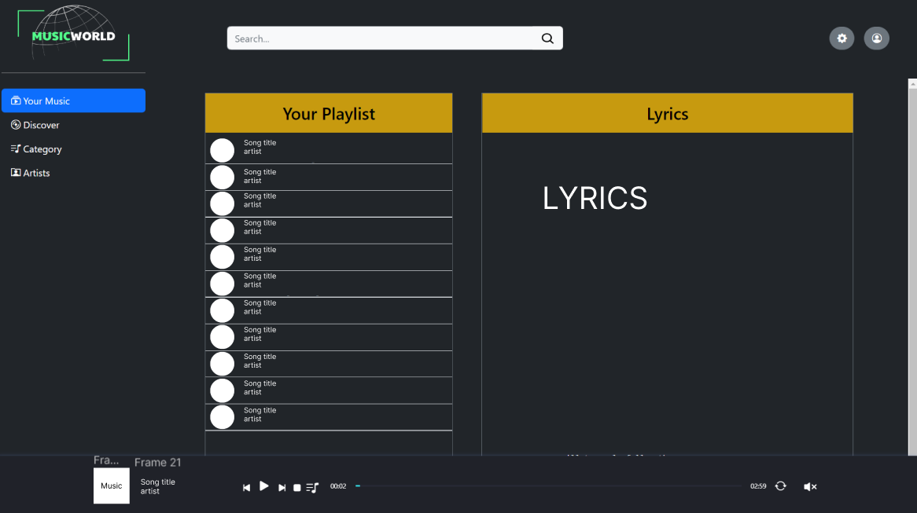

#### Discover

In the Discover menu, the user would be able to find information about New Releases, popular Artists in this page.

The content of Discover menu will be shown in main content page and scrollable.

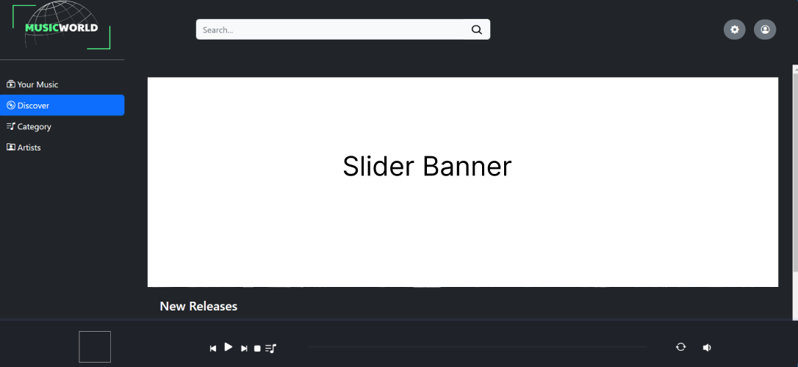

When clicking on an artist name, user will be redirected to Artist menu, where showing information about artist (Please check the Artist layout for more information).



#### Categories

Category contains Sub-Category items such as Genre, Nation, Mood, Event in which user can file type of music that he loves, for examples Rock genre, Pop genre, US-UK music in Nation category, and so on.

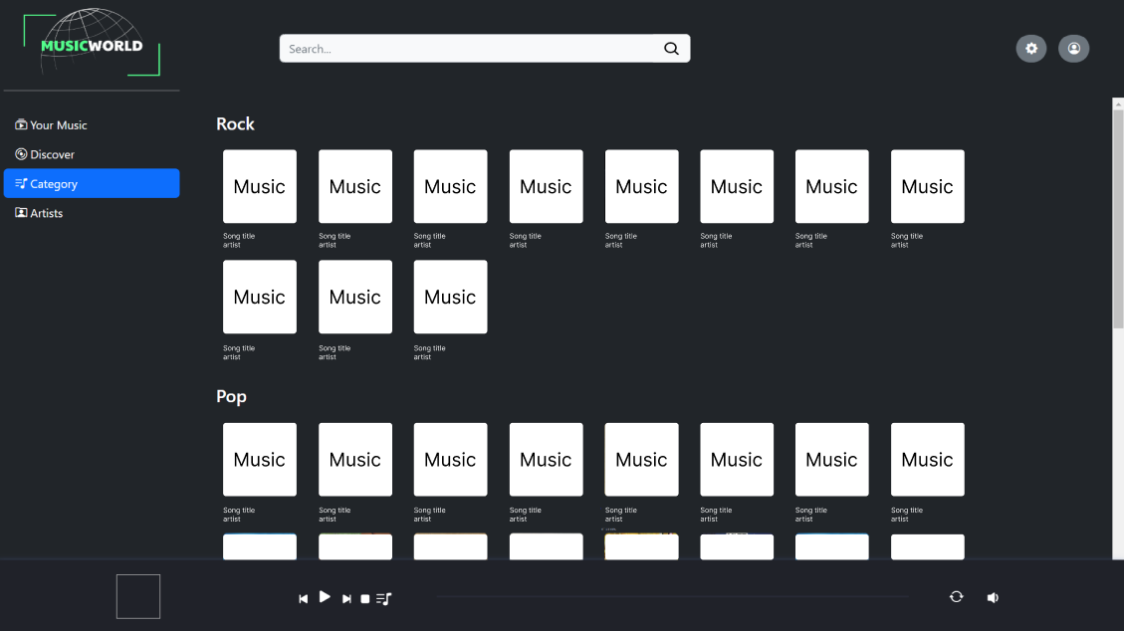

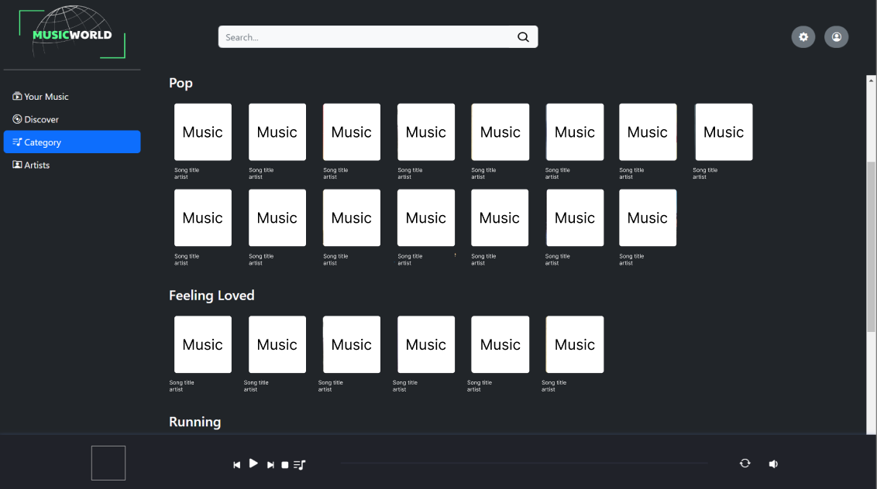

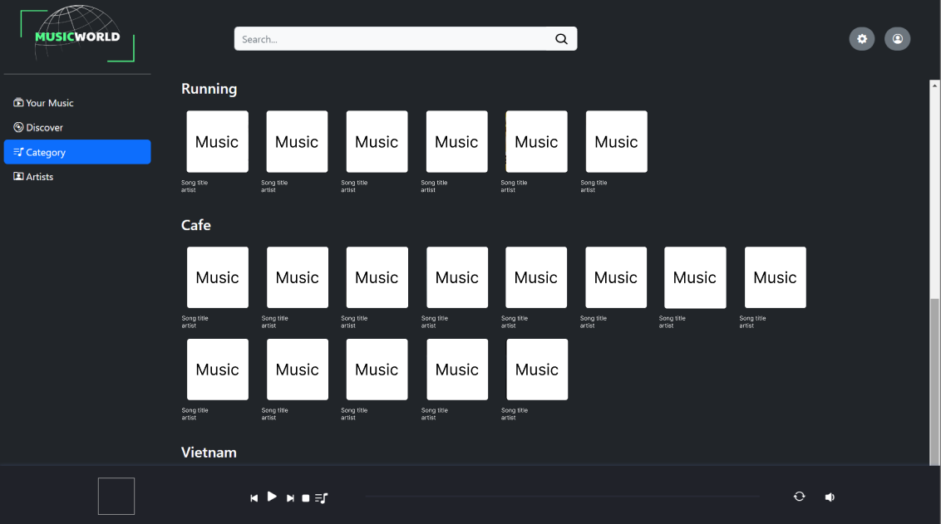

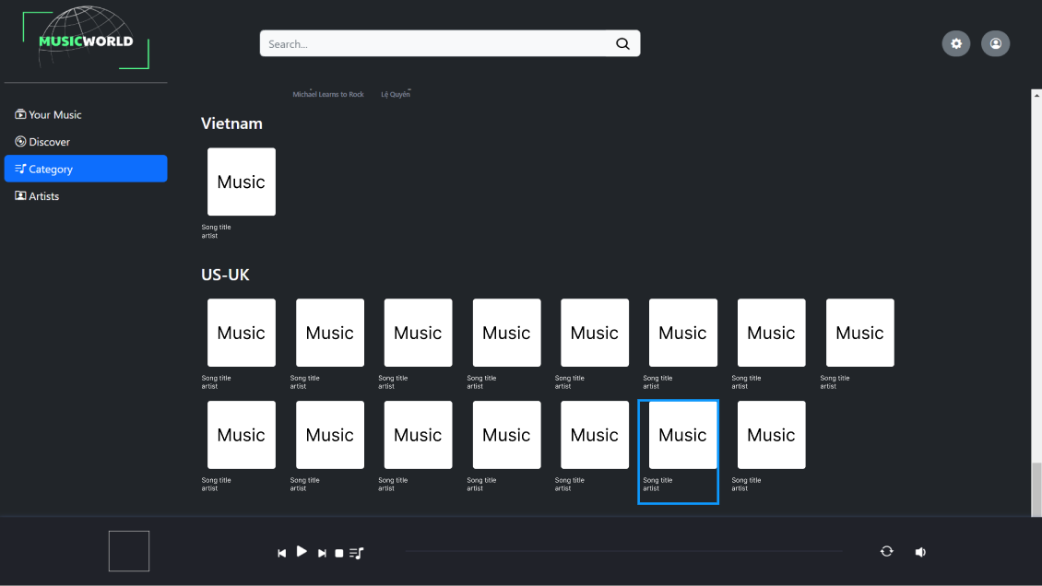

#### Artist

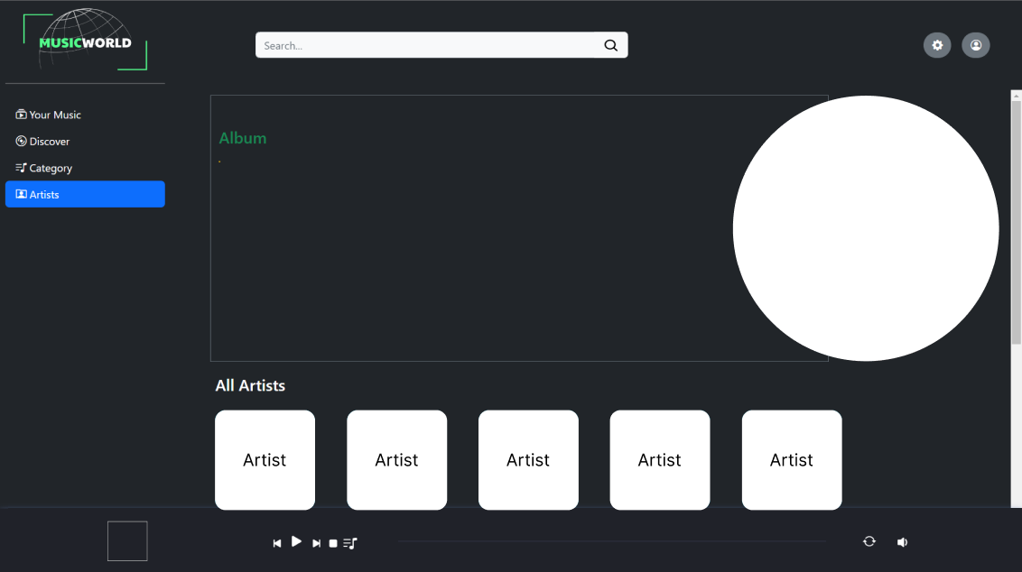

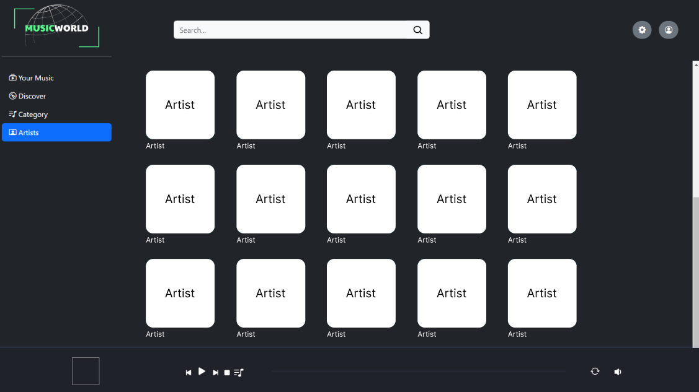

### Main Content

This place shows the details of Navigation Side bar.

When users click on any link on Navigation Side bar, details of that link will be shown as Songs, Albums, Artist information, related events.

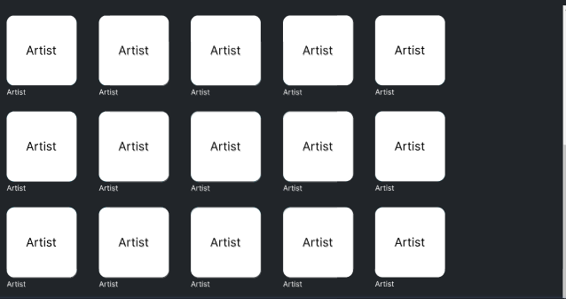

### Music Player

Music Player is divided into 2 main sections as shown in the following Figure:

* *Section 1*: Contain information about album art, song’s title, vocalist.
* *Section 2*: Music control panel where user can skip song, pause, shuffle, loop song in playlist, seeking duration bar, volume icon.



# REVIEW 2

## Website User Interface

### Homepage

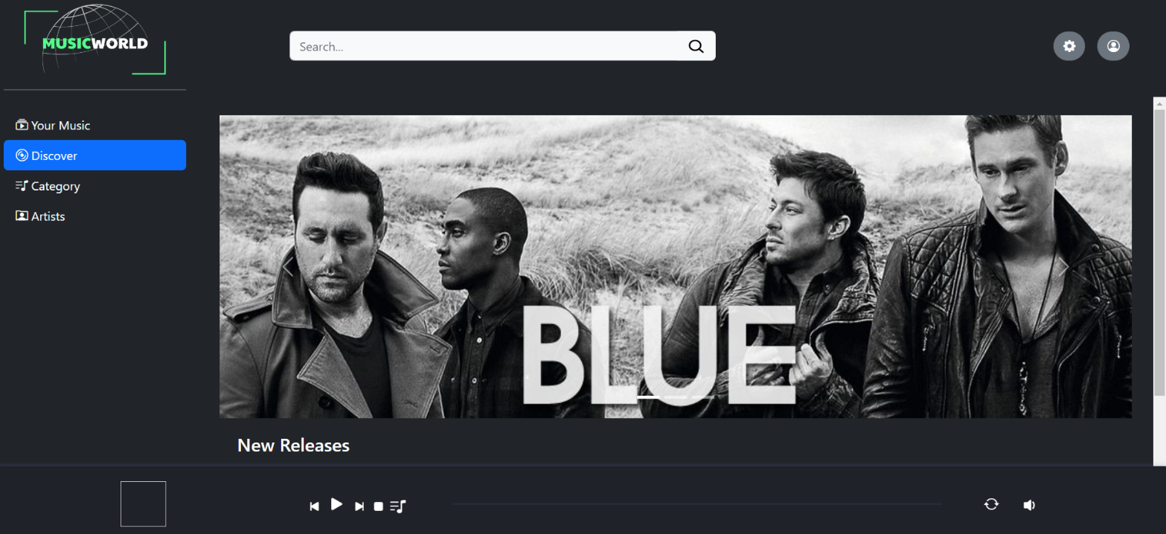

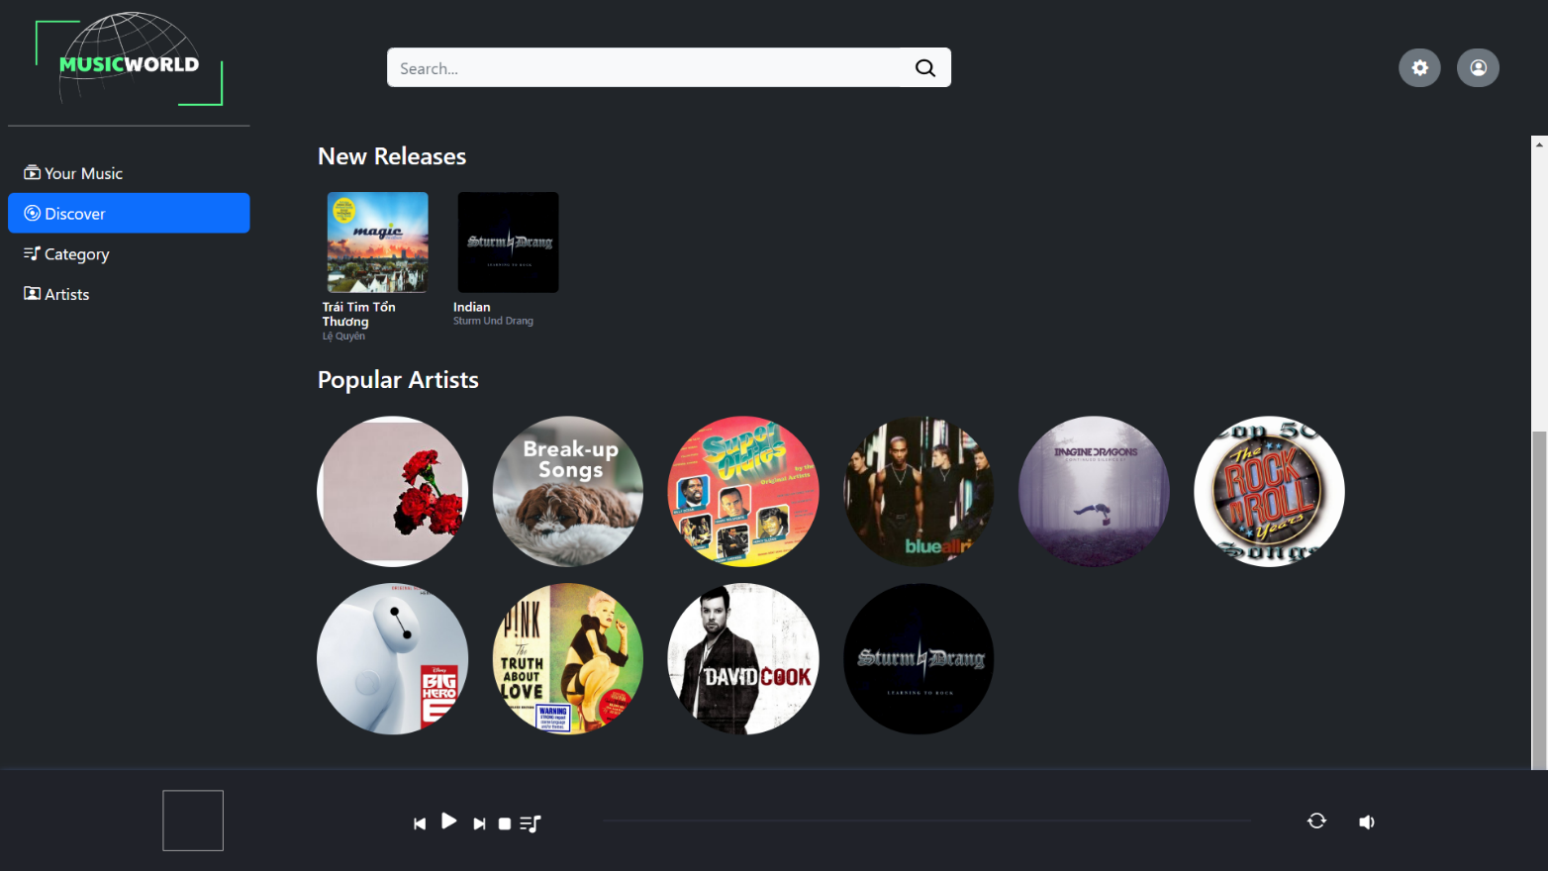

### Header

#### User Control

##### Sign In



##### Sign Up



#### Setting Control

##### About Us



##### Terms of use



#### Search box

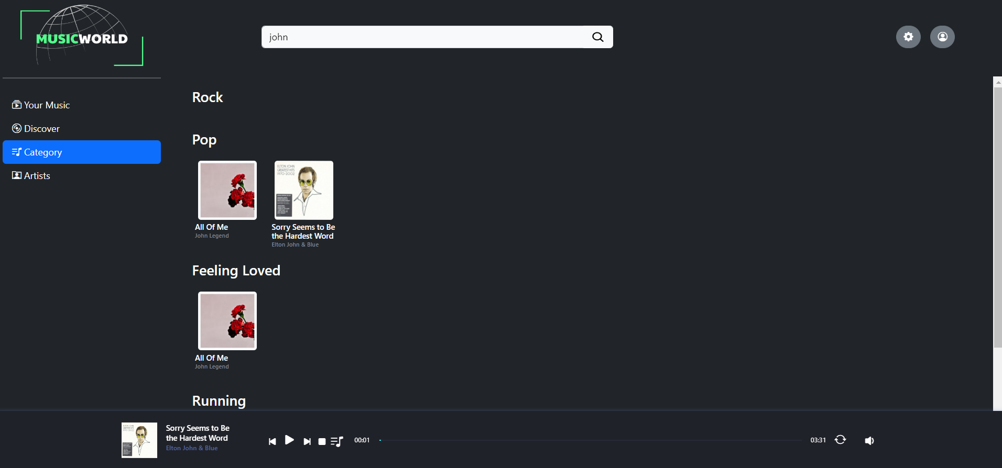

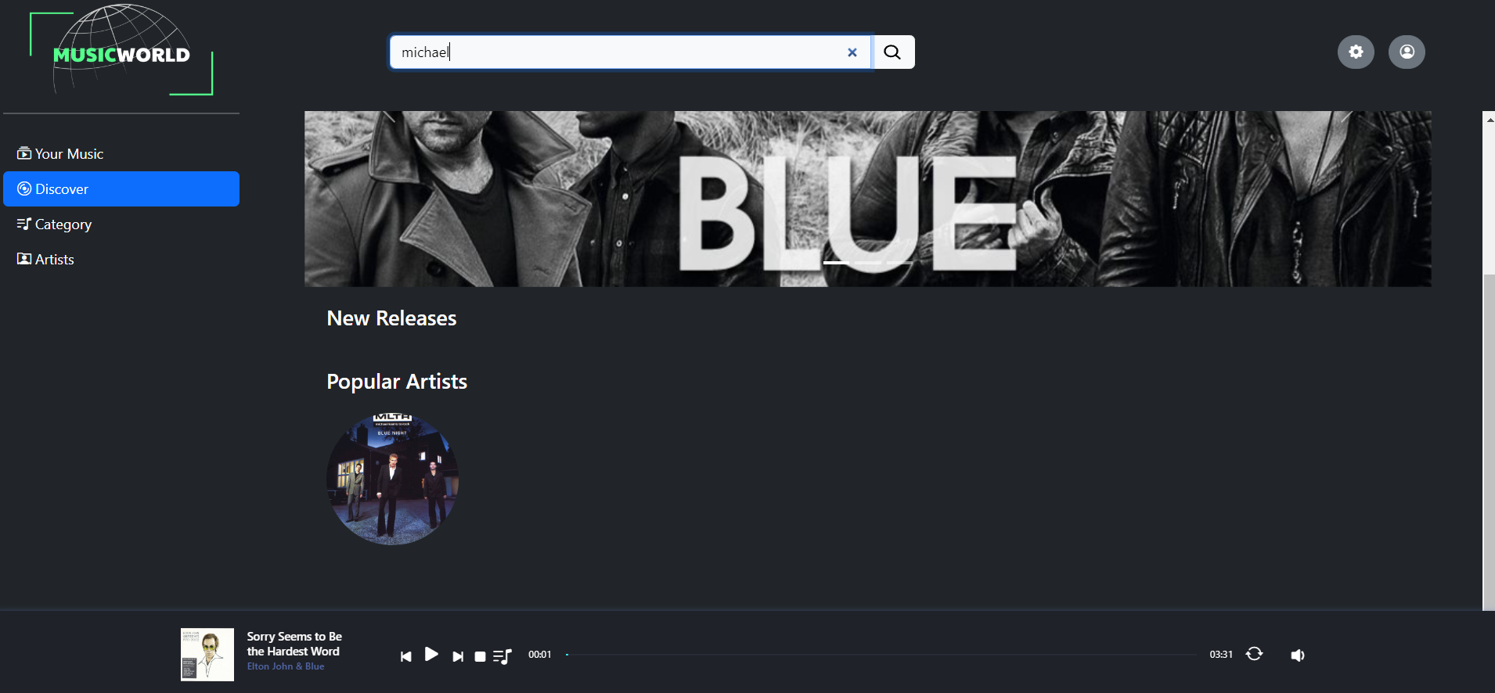

### Navigation side bar

#### Your Music



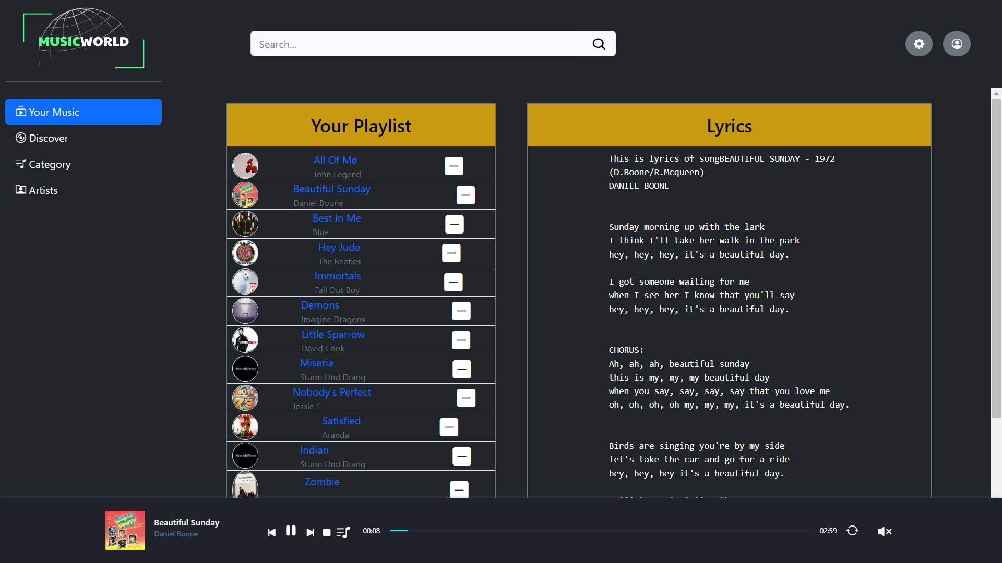

#### Discover

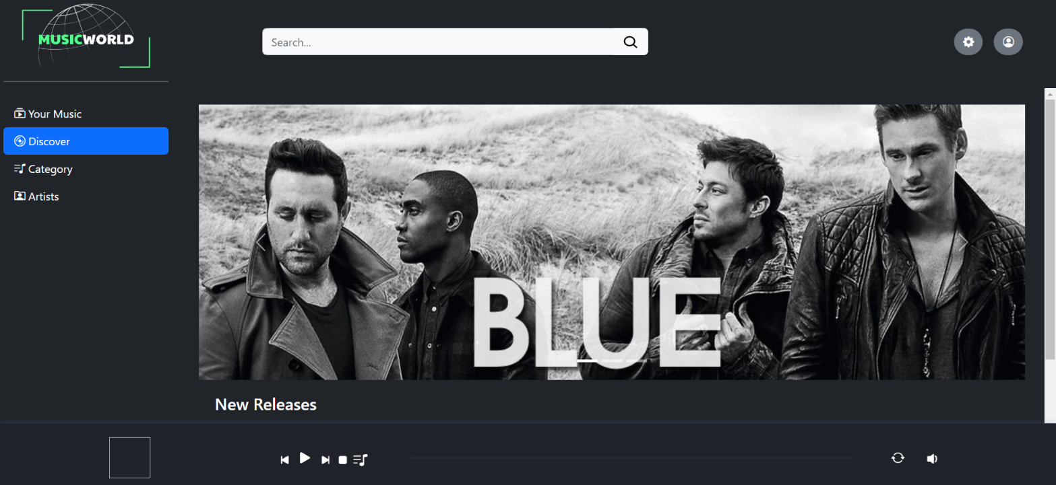



#### Categories

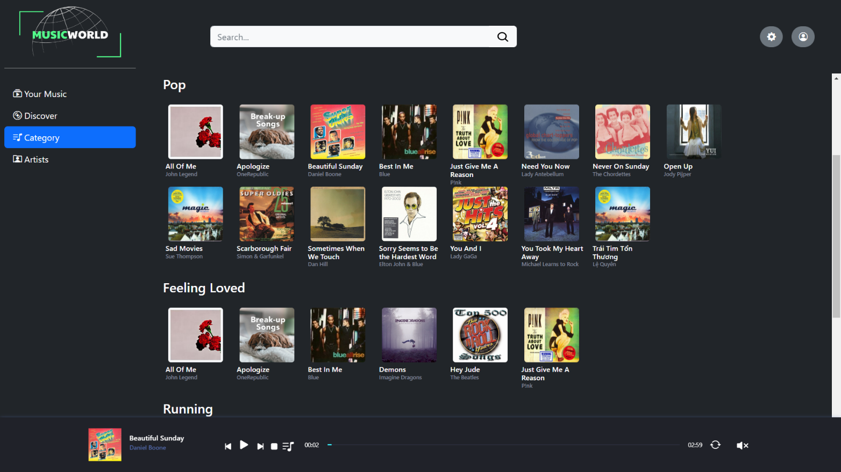

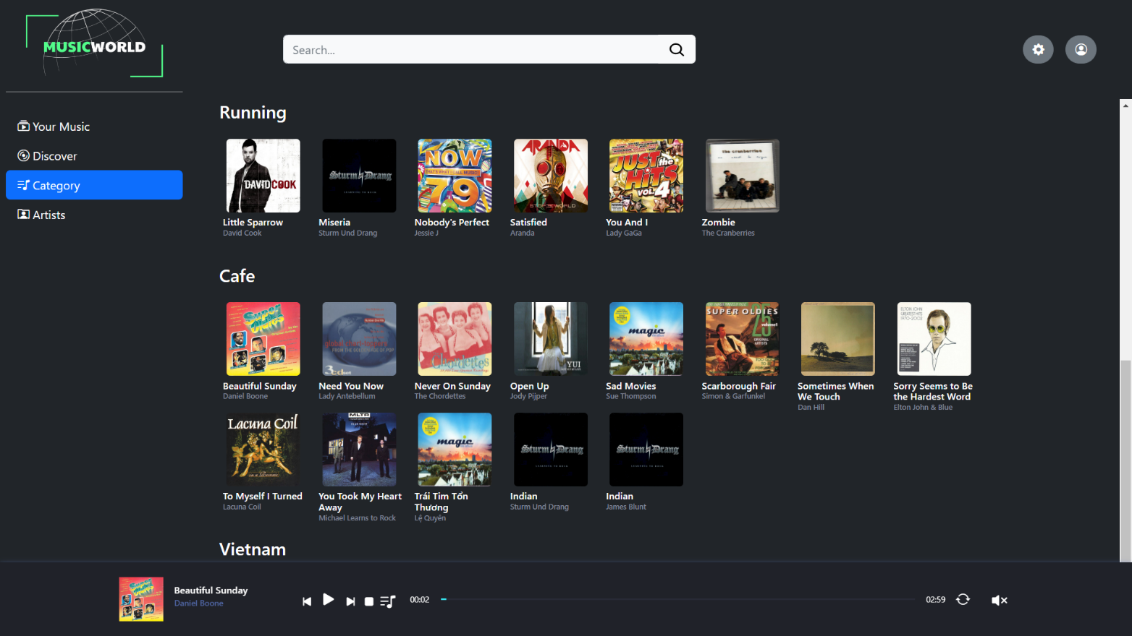

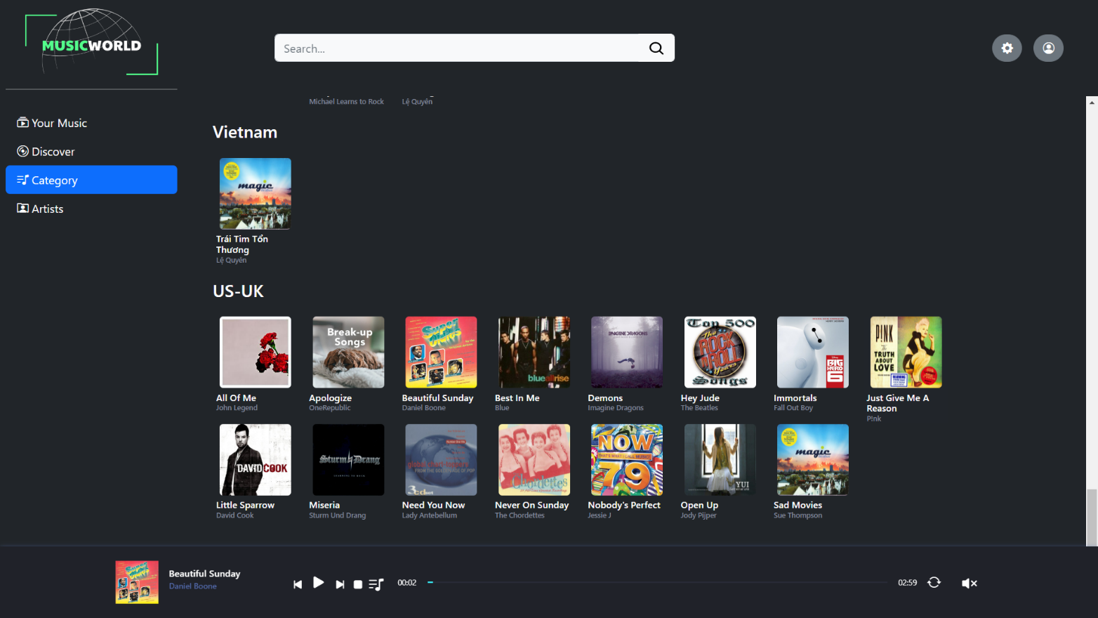

Figure : Category

#### Artist

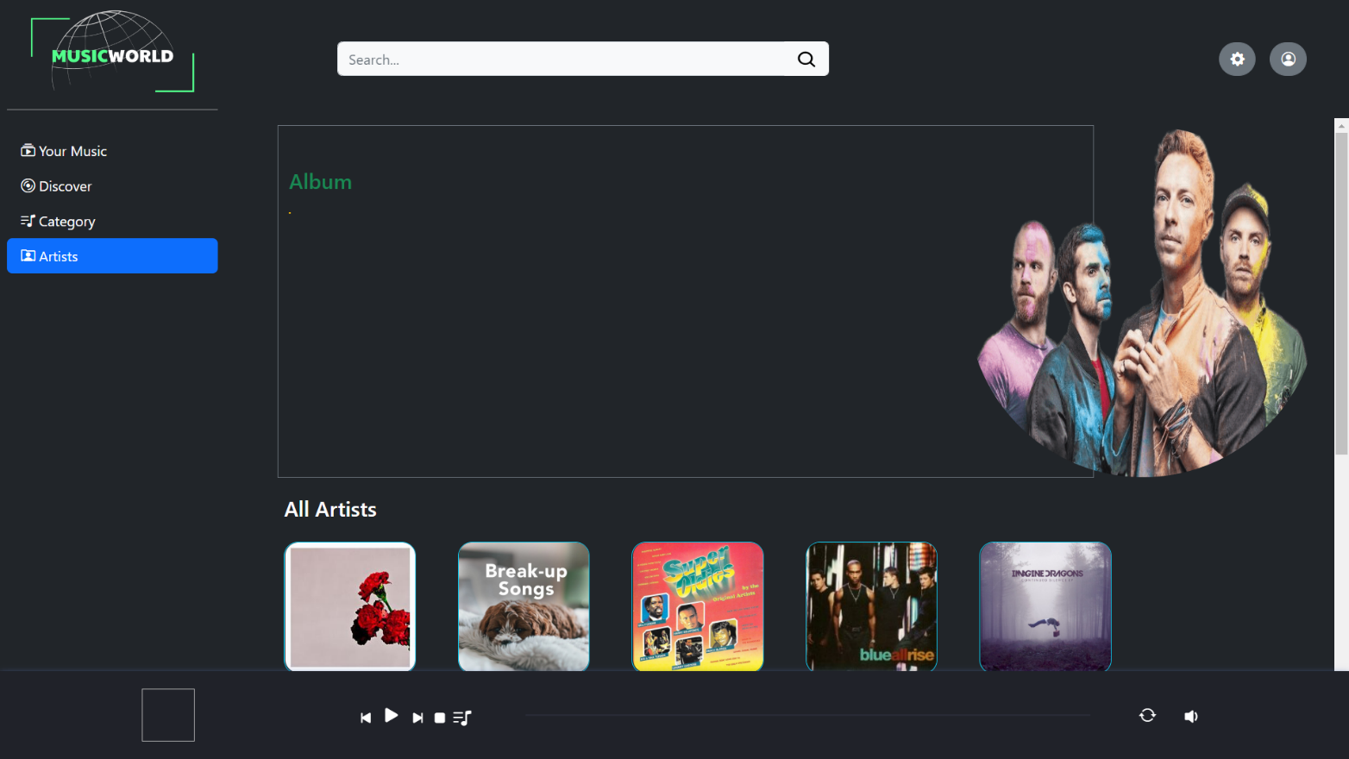

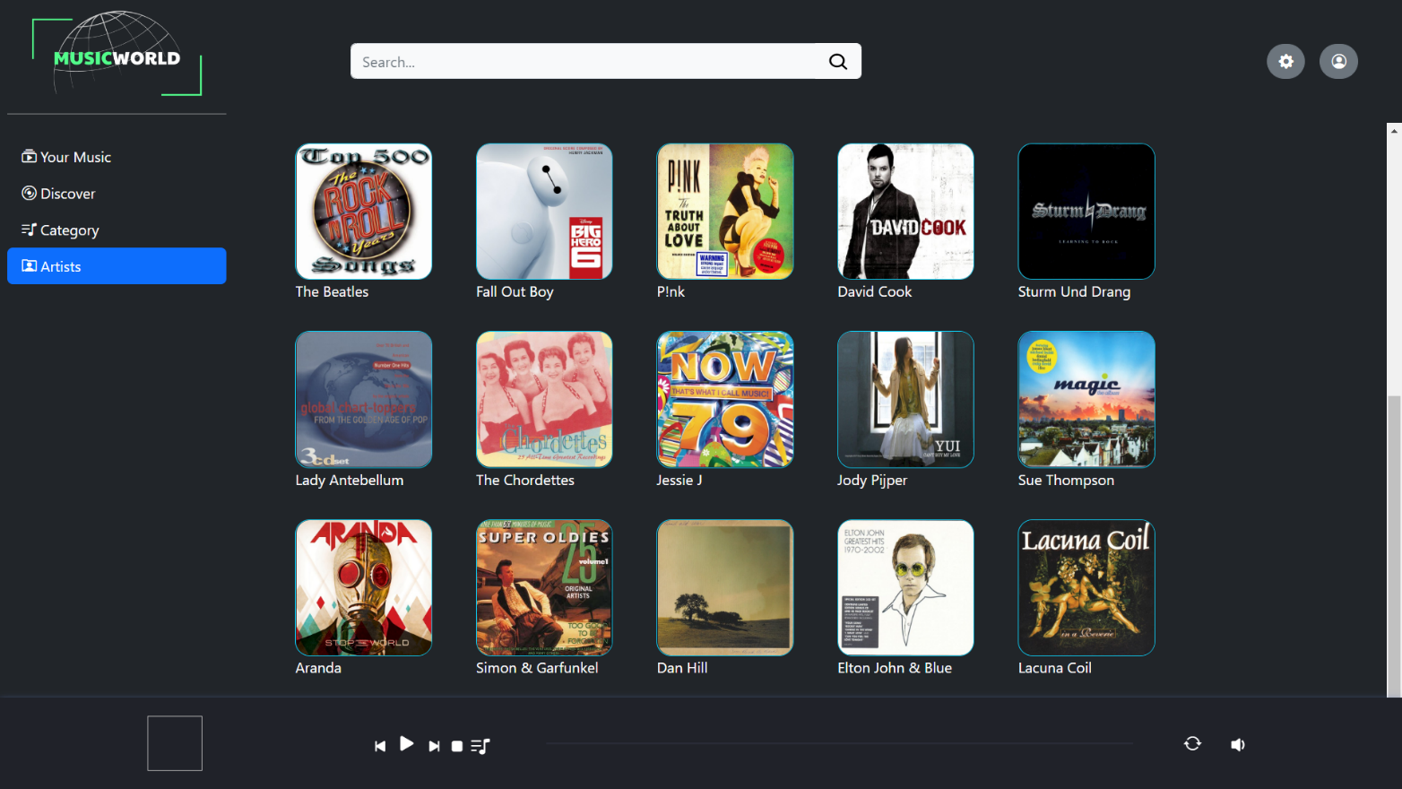

### Main Content

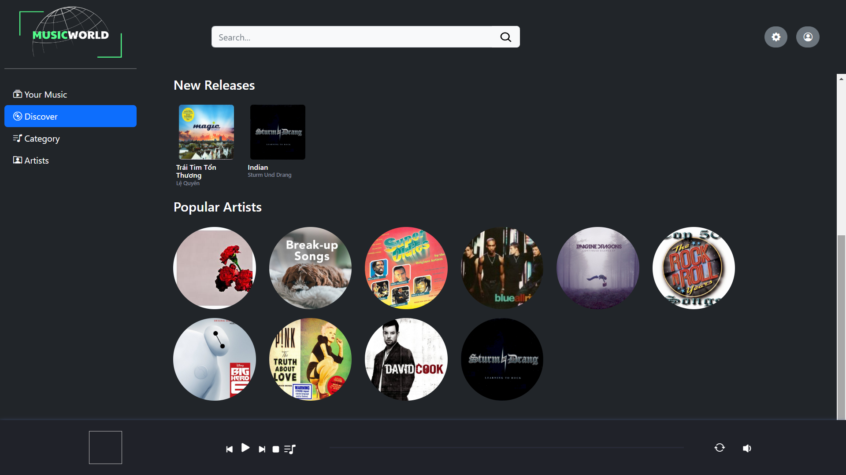

### Music Player

User who has registered account, the download button will be shown in this Music Player.

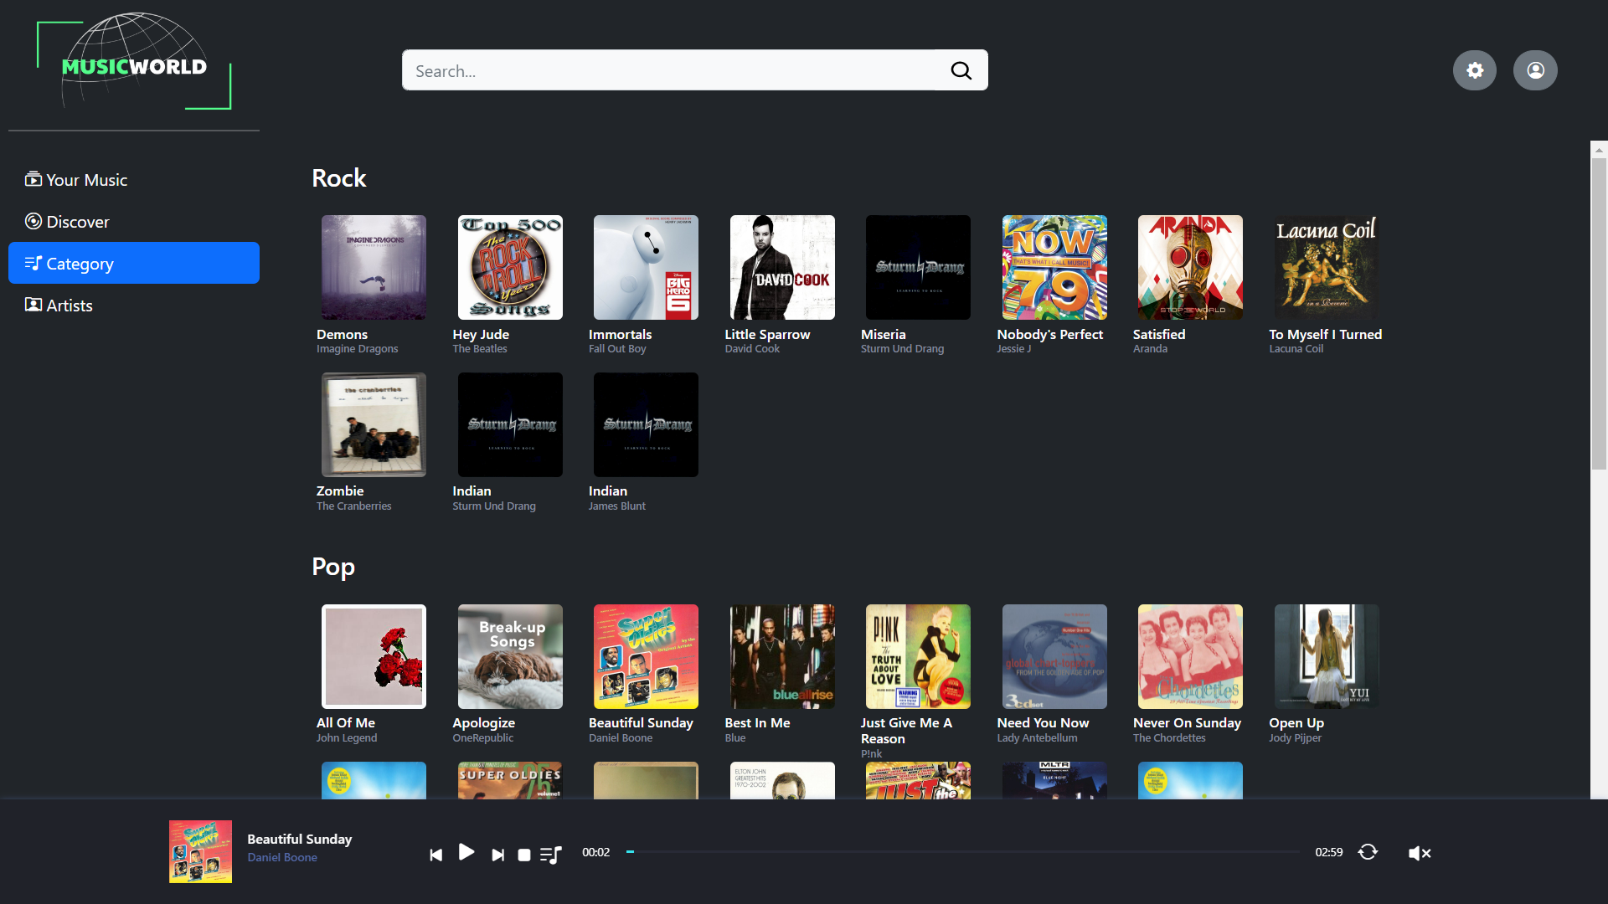



## Task Sheet

|  |  |  |  |  |
| --- | --- | --- | --- | --- |
| Task description | Assigned to | Progress | Start | Days |
|  |  |  |  |  |
| Defining the tasks of eProject. | Hung, Dieu, Chuong, Dung | 100% | 11/01/2022 | 1 |
| Concept ideas for project structure, concept of layouts based on functions of site | Hung, Dieu, Chuong, Dung | 100% | 11/04/2022 | 3 |
| Designing Logo, Site Map and Architecture of project | Hung, Dieu, Chuong | 100% | 11/07/2022 | 3 |
| Sketching general layout and sitemap | Hung, Dieu, Chuong | 100% | 11/09/2022 | 4 |
| Finalizing Layout and Sitemap for Review 1 | Dieu, Chuong | 100% | 11/14/2022 | 2 |
| Collect Assets (Media resources, related information) | Dieu, Chuong | 100% | 11/18/2022 | 3 |
| Design & Build Sign in | Chuong, Dieu, Dung | 100% | 11/30/2022 | 2 |
| Design & Build Sign up | Chuong, Dieu, Dung | 100% | 11/30/2022 | 2 |
| Design & Build Discover | Dieu, Dung | 100% | 11/20/2022 | 12 |
| Design & Build Categories | Dieu, Dung | 100% | 11/20/2022 | 12 |
| Design & Build Your Music | Dieu, Dung | 100% | 11/20/2022 | 12 |
| Design & Build Artist | Dieu, Dung | 100% | 11/20/2022 | 12 |
| Design & Build Term of Use | Dieu, Chuong | 100% | 11/25/2022 | 2 |
| Design & Build About Us | Dieu, Chuong | 100% | 11/25/2022 | 2 |
| Write Project Report | Dieu, Hung | 100% | 11/07/2022 | 25 |

## Testing document

|  |  |  |  |  |
| --- | --- | --- | --- | --- |
| **No** | **Features Tested** | | | **Remarks** |
| 1 | Are all the users able to view the images and links? | | | OK |
| 2 | Have all the views, modules and controllers been | |  | OK |
| properly integrated and is the site function as a single | | |
| page application? | |  |
| 3 | Are the GUI content devoid of spelling mistakes? | | | OK |
| 4 | Is the application user-friendly? | | | OK |
| 5 | Is the Website launching correctly in all popular | |  | OK |
| browsers? |  |  |
| 6 | Are all the forms validated with proper criteria? | | | OK |
| 7 | Do all text links lead to the appropriate website? | | | OK |
| 8 | Do all image links lead to the appropriate website? | | | OK |
| 9 | Are all the images and links clearly visible on the page? | | | OK |
| 10 | Does the Web page work properly in all the tested | |  | OK |
| browsers? |  |  |
| 11 | Does the Web page take too long to be loaded fully? | | | OK |
| 12 | Is the navigation sequences correct through all the Web | | | OK |
| pages on the site? | |  |
| 13 | Is the JavaScript code working as expected in all click | | | OK |

## Final checklist

|  |  |  |  |  |
| --- | --- | --- | --- | --- |
| **No** | **Features Tested** | | | **Remarks** |
| 1 | Are all the users able to view the images and links? | | | OK |
| 2 | Have all the views, modules and controllers been | |  | OK |
| properly integrated and is the site function as a single | | |
| page application? | |  |
| 3 | Are the GUI content devoid of spelling mistakes? | | | OK |
| 4 | Is the application user-friendly? | | | OK |
| 5 | Is the Website launching correctly in all popular | |  | OK |
| browsers? |  |  |
| 6 | Are all the forms validated with proper criteria? | | | OK |
| 7 | Do all text links lead to the appropriate website? | | | OK |
| 8 | Do all image links lead to the appropriate website? | | | OK |
| 9 | Are all the images and links clearly visible on the page? | | | OK |
| 10 | Does the Web page work properly in all the tested | |  | OK |
| browsers? |  |  |
| 11 | Does the Web page take too long to be loaded fully? | | | OK |
| 12 | Is the navigation sequences correct through all the Web | | | OK |
| pages on the site? | |  |
| 13 | Is the JavaScript code working as expected in all click | | | OK |

## References

1. Client-Server Architecture: <https://orangesoft.co/blog/introduction-to-server-testing>
2. Search tool: <https://www.google.com>
3. Problem solver website: <https://stackoverflow.com>
4. Improving knowledge to accomplish project: <https://www.w3schools.com/default.asp>
5. Improving knowledge to accomplish project (2): <https://getbootstrap.com>
6. Tool for layout and sitemap design: <https://www.figma.com>
7. Tool for logo design: <https://canva.com>
8. Tool for hosting free website: <https://github.com>
9. Tool for Music Player code: <http://perminder-klair.github.io/angular-soundmanager2>
10. Tool for Ui-Router: <https://ui-router.github.io>
11. Design idea: <https://zingmp3.vn>